Native American Cancer Research Corporation
3022 South Nova Road
Pine, CO 80470-7830
303/838-9359
E-MAIL: LindaB@NatAmCancer.net
WEB Page: www.NatAmCancer.org
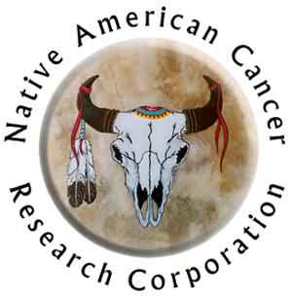

Video RELEASE FORM

I agree to be filmed, videotaped, and photographed by Native American Cancer Research Corporation staff, in connection with the continued development of Native American cancer education and survivorship support materials. I agree that the film, videotape, photographs, sound recordings and verbatim transcripts (the “materials”) may be used with such narration and other materials (including other recordings and photographs) as may deem appropriate in print, film, web and other formats. I represent and warrant that my acts and statements contained in the material will not violate any rights of any other person or company.

I understand that Native American Cancer Research Corporation (NACR) is a community-based, non-profit corporation and will not receive any profits from my participation. NACR will own all rights in the material and program. NACR will have the right to distribute, exhibit, and otherwise, use the material forever, in all or in part, throughout the world, in any media as part of the project and in advertising and publicity for the project, as well as in connection with any other program. In no case will any consideration of additional consent be required to permit NACR’s use of the Material.

I understand that this agreement does not obligate Native American Cancer Research Corporation to use any of the Material, or to exercise any rights granted by me in this consent.

_________________________________________________________________
Signature Date

_________________________________________________________________
Printed Name Tribal Affiliation

_________________________________________________________________
Street Address (please print) City State Zip Code

_________________________________________________________________
Type of cancer Year Diagnosed Stage of cancer at diagnosis

Please turn this over to let us know what you want to talk about

Stories I’d like to share with other survivors (please include how you dealt with the situation):
- Physical Activity
- Oral / throat Side Effects
- Improving communication with provider
- Pain
- Side effects: Nausea, vomiting, mouth sores, numb body parts, etc.
- Fatigue / tiredness / weakness
- Clinical Trials
- Surgery
- Radiation (external, internal [Brachytherapy])
- Chemotherapy
- Hormonal therapy
- Combination of diabetes and cancer
- Healthy eating
- Physical therapy to help recovery
- Physical activity
- Sexuality, intimacy, reproduction
- Spirituality
- Caring for the chronically ill or dying family member / loved one
- Medicaid, Medicare, Americans with Disabilities Act or payment issues
- Other, write-in _________

